A model for deceased-donor transplant queue waiting times

Steve Drekic · David A. Stanford · Douglas G. Woolford · Vivian C. McAlister

# Abstract

In many jurisdictions, organ allocation is done on the basis of the health status of the patient. This paper presents a priority queueing model for patient waiting times which takes into account changes in health status over time. We model the queueing system as a level-dependent quasi-birth-and-death process, and the steady-state joint queue length distribution as well as the marginal delay distributions for each queue are computed via the use of matrix analytic techniques.

# Introduction

The “Model for End-stage Liver Disease (MELD) Score” is a means for ranking patients periodically so that those whose health status was degrading more quickly would gain priority. The resulting service discipline does not fit into the realm of existing FCFT or priority queueing models, since a wait-listed patient’s priority depends upon their health status, which in turn is influenced by the amount of time they have spent waiting.

The goal of this paper is to present a full analysis and application of a queueing model which we develop for liver transplant patients of each ABO blood type that reflects the sickest patient first aspect and allows for abandonments.

* We derive the steady-state queue length and marginal delay distributions.
* We derive estimators for the parameters
* We calibrate and assess the fit of the model using real wait-list data.

Our work demonstrates how queueing theory can produce a model which can be used to provide a reasonable indication of key performance measures, such as the likelihood of successful transplantation, and the likelihood of abandonment or death while waiting.

The distinguishing factors which arise in transplant queue settings are:

* queue abandonment due to death, a degradation or improvement in health status or personal reasons;
* service discipline: many transplant queues do not typically follow a FCFT discipline, but instead treat wait-listed patients who experience a degradation in health status on a priority basis. Patients “self promote” from regular status to priority status at an exponential rate, while waiting (“priority jumps”).
* patient and donor ABO status: organs are routinely allocated on an ABO-identical basis. Rules for access to ABO-compatible organs on the basis of urgent need vary depending on the organ to be transplanted and the jurisdiction.

There are interlinked wait lists: in the data used for model calibration, we will aggregate both ABO-identical and ABO-compatible organs that were transplanted into patients of each of the four blood types.

The model presented herein is one for deceased-donor transplant wait lists.

Examples of policy changes that would likely impact waiting time include:

* the merging of formerly separate wait lists,
* changes in policies regarding ABO-identical versus ABO-compatible cross-transplantation,
* a decrease in deceased-donor organ rates due to improvements in accident prevention,
* in the case of kidneys, a change in demand for deceased donor organs due to the increased use of “transplant chains” involving living donors.

The work presents a model for patients of each ABO blood type that can be used to provide a reasonable indication of the relative likelihood of the possible outcomes that individual patients can experience:

* successful transplantation prior to perceived health degradation,
* successful transplantation as a priority patient due to health degradation,
* the likelihood of abandonment or death while waiting,
* estimates of the time spent waiting.

# Description of the queueing model

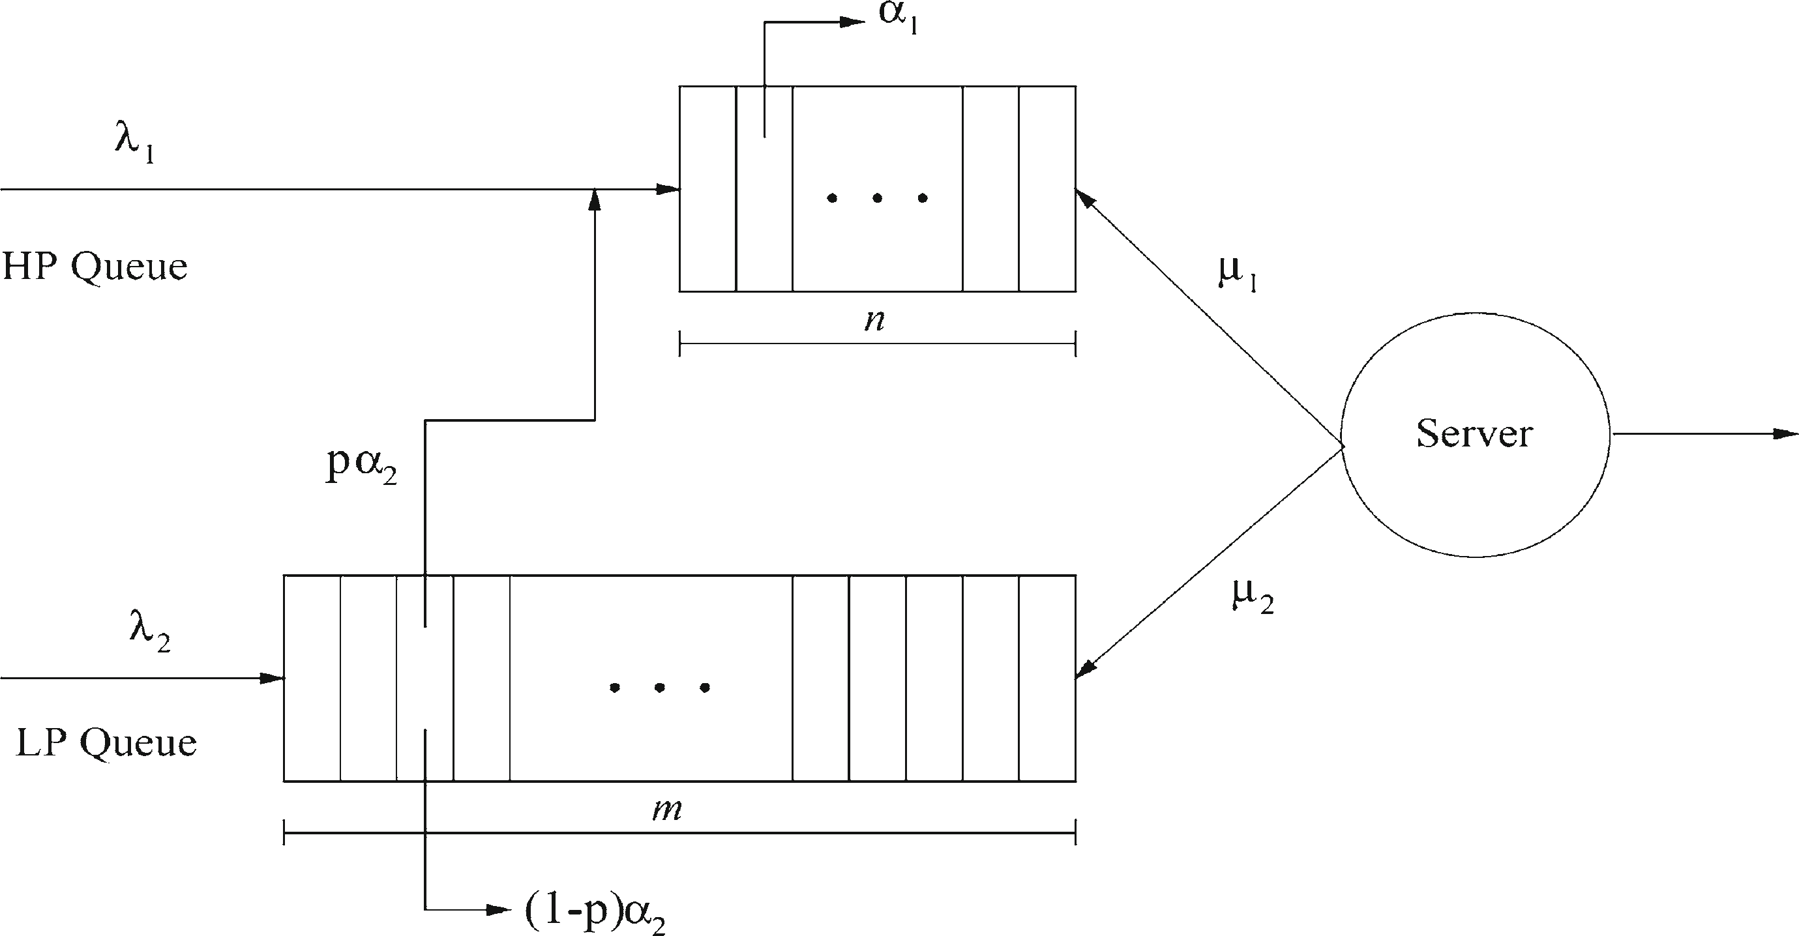

A single server provides service to two classes of transplant requests, each having its own respective line. Wait-listed patients are served on a FCFT basis within their own line. As organ availability is the limiting factor, the service time constitutes the interval from when a wait-listed patient reaches the head of their queue until an organ becomes available. Furthermore, class 1 has preemptive priority over class 2, implying that a class-2 patient in service would be preempted by an arriving class-1 patient to the system.

Let

* $m<∞$ and $n<∞$ be the buffer sizes of the LP and HP queues.
* $λ_{1}$ and $λ_{2}$ be the independent Poisson arrival rates of HP and LP patients to the system.
* $μ_{1}$ and $μ_{2}$ be the individual independent and exponentially distributed HP and LP service rates.

We distinguish between the reneging/abandonment behaviours of the two patient classes.

* At the class-1 level, reneging patients leave the system at rate $α_{1}$ and are unrecoverable (reflecting deaths and “coming off-list”).
* At the class-2 level, patients renege at rate $α_{2}$, and either:
  + leave the system with probability $q$ (deaths and “coming off-list”)
  + are promoted to the end of the HP queue with probability $p=1-q$ (degraded health status still suitable for transplantation).

We determine the following main performance measures:

1. The steady-state joint queue length probabilityfor the number of HP $\left(X_{H}\right)$ and LP patients $\left(X_{L}\right)$ present in the system 🡪 , the respective LP and HP blocking probabilities

🡪

🡪

1. The CDF and moments related to:
   1. 🡪 the stationary waiting time of an originally arriving HP patient who successfully completes service prior to reneging.
   2. 🡪the stationary waiting time of an arriving LP patient who successfully completes service within the LP queue prior to reneging.
   3. 🡪the stationary waiting time of a promoted LP patient from the point of transfer to the HP queue until that patient successfully completes service prior to reneging.
2. The probabilities representing the various likelihoods that a patient reneges prior to receipt of an organ:
   1. HPRenege 🡪 the probability that a patient who arrives as HP will renege,
   2. LPRenege 🡪 the reneging probability for a LP patient,
   3. PromLPRenege 🡪 the reneging probability for a HP patient who initially arrived as LP.

# Determination of the steady-state probabilities

…

# Delay distributions for HP transplant requests

…

# Delay distributions for LP transplant requests

…

Upon entry to the system, our tagged Poisson-arriving LP patient must not only wait for all LP patients in front of it to clear, but for *all* HP patients, including those present upon arrival as well as those arriving later to be cleared from the system. This potentially includes promoted LP patients who queued behind the tagged LP patient. As a result, $W_{L,1}$ can be modelled as the time to absorption in a Markov chain with infinitesimal generator.

…

As a means of identifying the proper initial probability vector to use, we track the potential path our tagged LP patient can take with respect to three distinct *final* outcomes within the LP queue. We label these final outcomes as follows:

* *F*1 ≡ tagged LP patient completes successful service in the LP queue,
* *F*2 ≡ tagged LP patient reneges and exits the system from the LP queue,
* *F*3 ≡ tagged LP patient receives promotion to the HP queue.
  + *F*3 can be further broken down into the outcomes in which our tagged LP patient finds *i* class-1 patients ahead of it upon promotion.

# Model calibration via a parametric competing risks framework

The cause for a patient to leave the queue (abandonments and self-promotion) needs to be tracked as well as their time in the system; such data can be modelled using a “competing risks” framework.

We are interested in simultaneously modelling more than one event time variable. Consider the arrival of a LP patient, who can exit the LP queue. If such a patient left the system as a result of obtaining a transplanted organ, then we know not only the exact time of this event, but we also know that their time to renege would have been longer. Conversely, had the patient reneged, then their time to transplant would have been right censored.

We have assumed that external arrivals to both queues follow independent Poisson processes and that the transplant and reneging times are exponentially distributed. In this parametric modelling context, it is possible to construct a likelihood function that incorporates the notion of a competition between the class-specific transplantation and reneging rates. Given data, the model can then be calibrated by estimating the parameters using a maximum-likelihood-based approach.

The suitability of assuming exponential inter-availability times was discussed at length in Stanford et al. [21], and that result was employed in [22] to show why it is reasonable to make that assumption in the presence of random ABO-compatible transplantation.

The system times of successive patients are highly correlated since successive system times in a heavily loaded queue will have a great degree of overlap. The sequence of observed “inter-exit times” within each priority stream, we assume, are at least approximately independent.

In our framework, the probability $p$ of being promoted to HP status occurs at random. LP patients who renege are considered to either immediately “self-promote” to the HP queue with probability $p$, or to exit the system with probability $q=1-p$, independently of the others. The total number of reneging LP patients who become promoted is thus a binomial random variable, whose MLE $p$ is well known to be the empirical proportion of “successes”. In our context, $p$ is the observed proportion of reneging LP patients who receive promotion to the HP queue.

The LP and HP streams are analysed separately due to the assumption that HP patients are served on a FCFT basis, regardless as to how they entered that queue.

# Case study: analysis of liver transplantation data

Donor livers are typically allocated and transplanted regionally (LP). However, patients considered “high-status patients” are placed on a national wait list (HP).

The model was run under three scenarios, one for each of blood type, corresponding to the sets of parameter estimates given.

The buffer sizes used for our model, along with the corresponding set of blocking probabilities obtained, are displayed for each blood-type-specific case. The chosen values for *m* and *n* yield negligible blocking probabilities in all cases.

The LP system empirical behaviour is consistent with the operation of a wait list involving three priority levels. Specifically, patient codes 0 through 3 are being further pooled into two distinct priority classes, and not a single class as we have considered here. A three-class analogue of the model being presented here should be pursued.

We remark that the existence of a multi-level clinical distinction of patient acuity rarely translates operationally class for class. Typically, there are either two or three priority classes. An iterative model building approach, aided by expert perception of what is occurring, medically and mathematically, is therefore needed to determine the number of priority classes in operation.

Results seem to suggest that our model of LP system time fails to capture the high observed variability in waiting times, and the HP models are generally overly conservative. Future work will need to pursue all of the following avenues:

* revisiting the model assumptions regarding placement and abandonment rates,
* refining the parameter estimates and testing the model against observed data from other wait lists.

# Concluding remarks

Performance measures of interest we obtain include

* the waiting time distributions and their moments,
* the queue length distributions and the reneging probabilities.

These results are obtained for patients who:

* are urgent when placed on the wait list,
* have a regular status and receive their organ in regular status,
* become urgent from regular status placements prior to transplantation.

The results take the form of:

* matrix geometric solutions for the queue lengths and phase-type distributions for the waiting times,
* maximum-likelihood-based procedure for estimation of the model parameters.

These results were then applied to study a single liver transplantation centre. Whereas the fit of waiting time for patients transplanted with an urgent status appeared to be appropriate, the fit for the regular stream of patients was deemed inadequate, since it appeared that the wait list comprised three priority classes operationally.

Future work will proceed along two directions:

* apply the data to other transplantation centres, to see if our two-class priority model is appropriate.
* extend the existing results to allow for a third priority class.

The assumption that all blood types have the same propensity to renege per unit time waiting is consistent with the medical view that blood type does not influence health degradation. Nonetheless, the longer a patient waits, the greater the chance for that patient to experience degraded health.

CITAZIONE

@article{article,

author = {Drekic, Steve and Stanford, David and Woolford, Douglas and Mcalister, Vivian},

year = {2014},

month = {01},

pages = {87-115},

title = {A model for deceased-donor transplant queue waiting times},

volume = {79},

journal = {Queueing Systems},

doi = {10.1007/s11134-014-9417-7}

}